**Assembly Instructions**

**Required materials :**

**Case**

Case - 3d printed case.stl x1

Lid - 3d printed lid.stl x1

Adafruit Feather nRF52840 Express x1

3.5mm socket 4 pole TRRS x5

Power switch x1

Lithium ion polymer 3.7v battery x1

JST PH 2-pin female cable x1

JST PH 2-pin male cable x1

Solder tubes x4

M3 by 25mm flathead bolts x4

M3 nuts x4

M2.5 by 10mm bolts x2

M2.5 nuts x2

Hookup wires

**Gyroscope and Earpiece**

gyro cover.stl x1

earpiece.stl x1

Adafruit LSM6DSO32 x1

STEMMA QT 4-pin cable x1

3.5mm male plug to bare wire 4 pole x1

Solder tubes x4

M1.7 electronics screw x4

**Case**

1. Wire the 5 3.5mm sockets

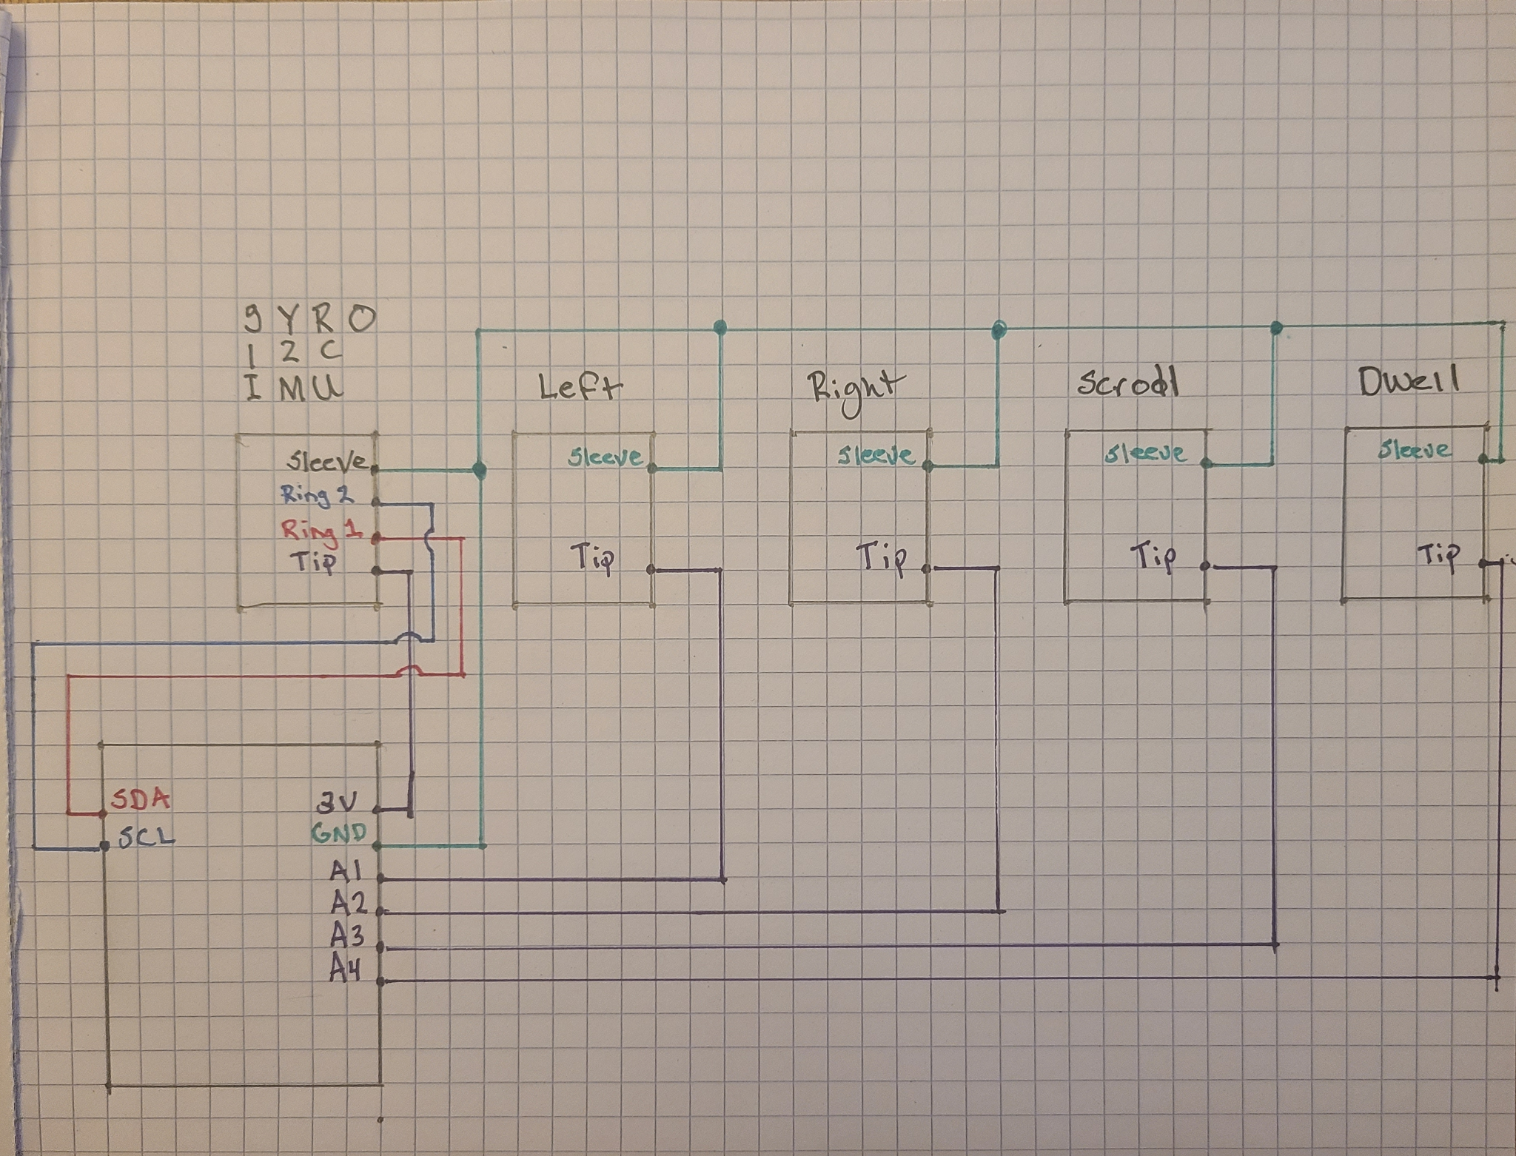

*** INSERT PIC OF WIRED PLUGS

1. Solder screw terminals to nRF52840
2. Wire 3.5mm plugs to nRF52840
3. Splice JST PH cables(female and male) using solder tubes
4. Connect battery, power switch and nRF52840 feather

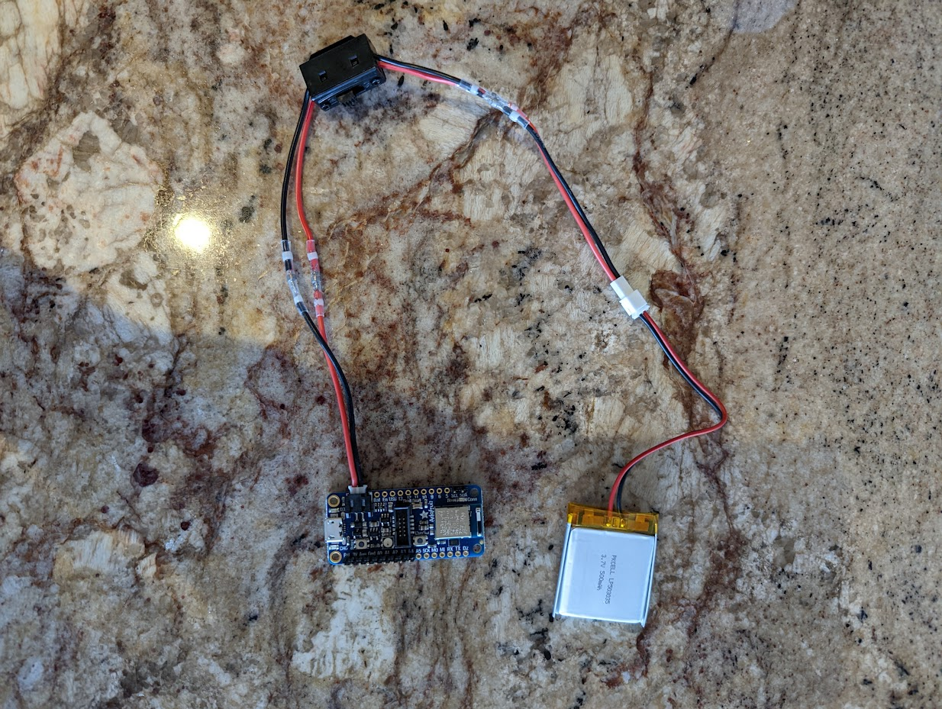

1. Use M2.5 bolts and nuts to attach the nRF52840 feather to the case
2. Secure the 3.5mm sockets to the case with the panel mount nuts
3. Secure the power switch to the case by removing the two screws and faceplate and reattaching through the holes in the case
4. Secure lid with the M3 bolts and nuts

**Gyroscope and Earpiece**

1. Splice STEMMA QT cable to 3.5mm male plug using solder tubes

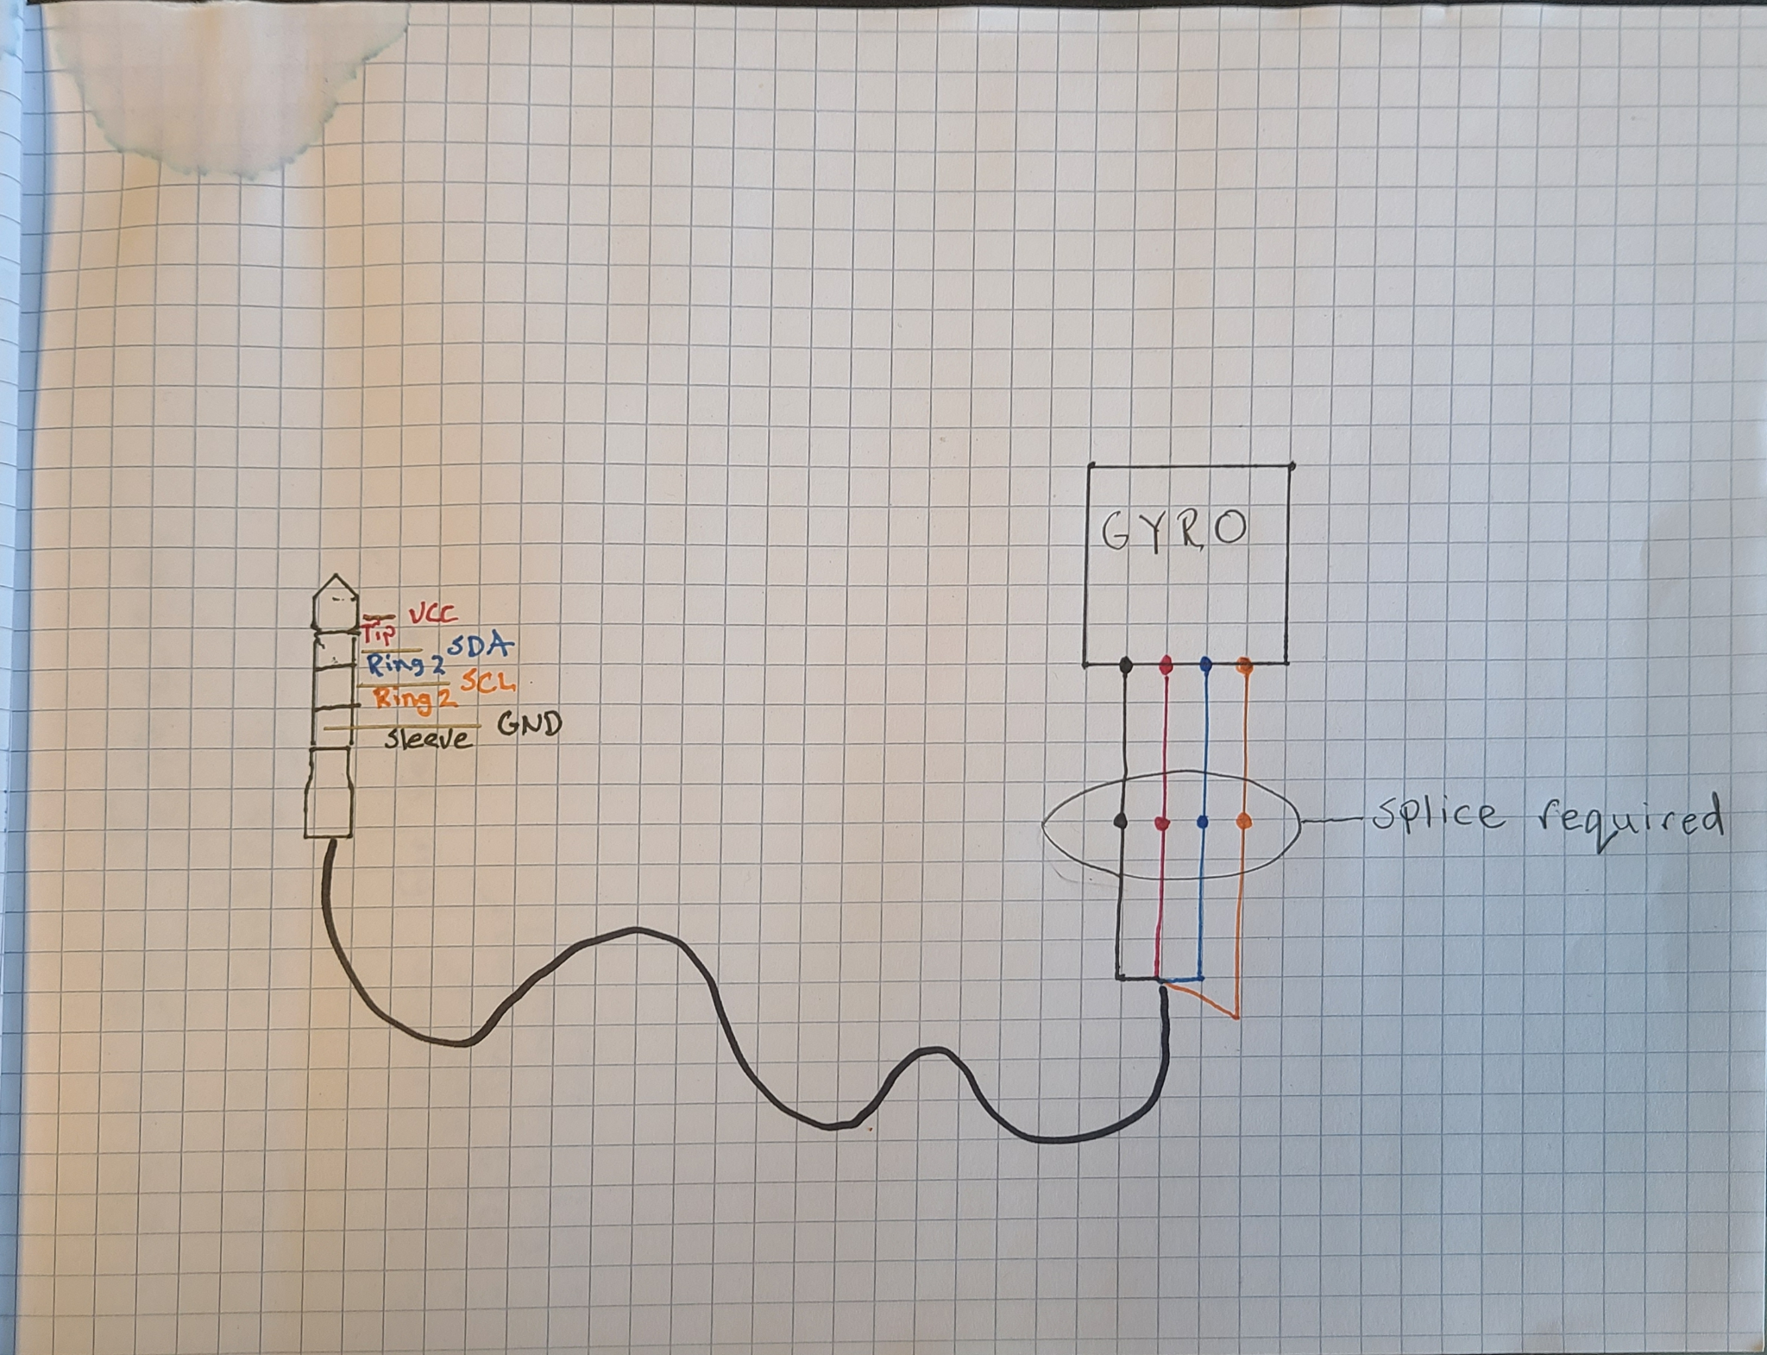

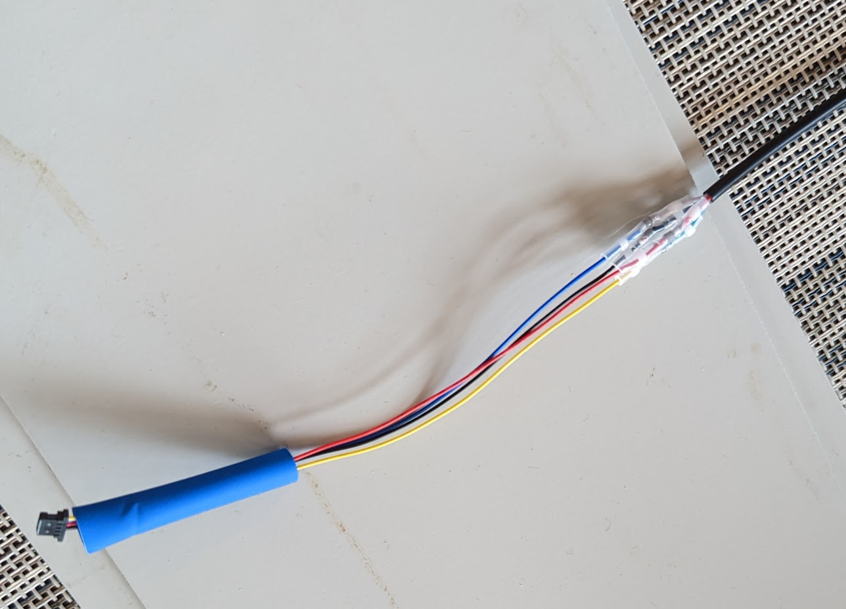

1. Heat shrink to cover the splice3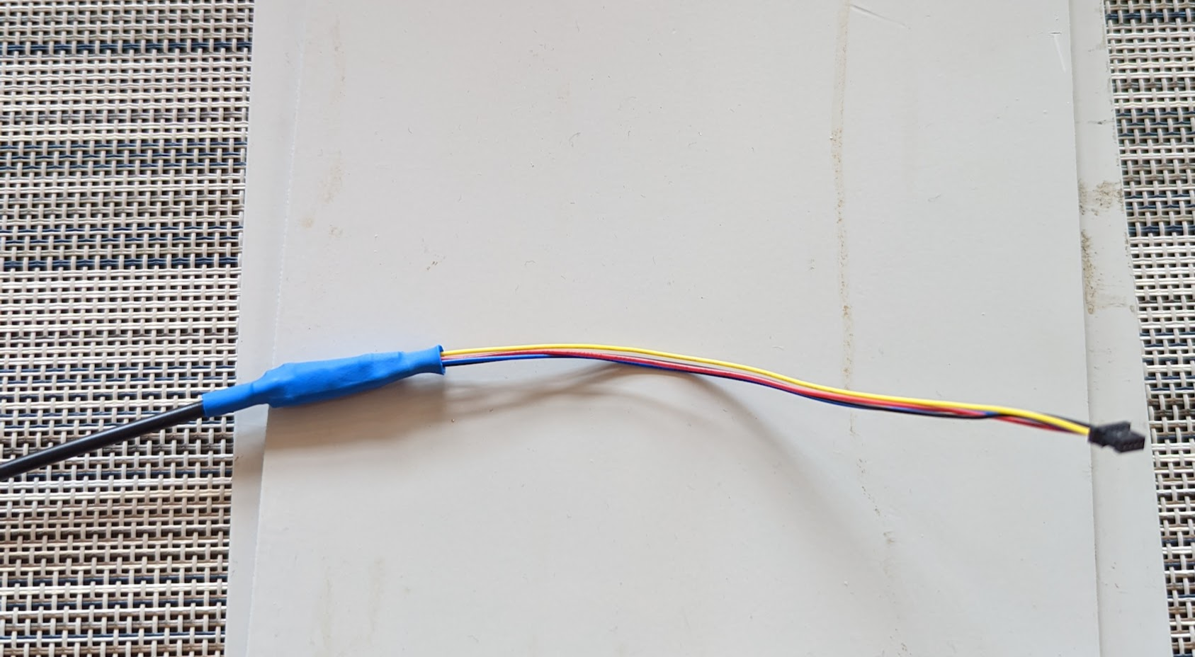
2. Attach gyro cover to LSM6DSO32 gyroscope with m1.7 screws

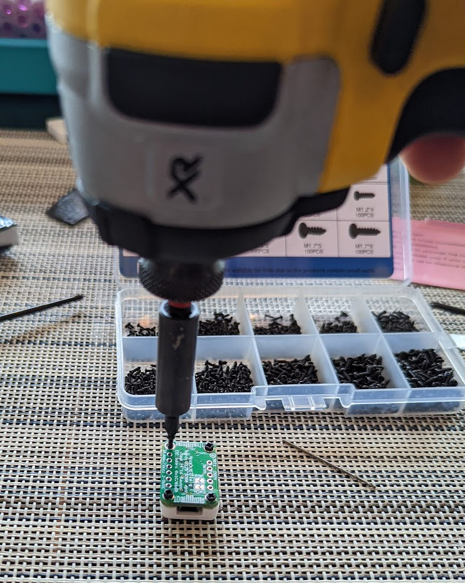

1. Apply velcro tape to gyroscope and the flat side of the earpiece

